Fun with HTML and JavaScript

We’re going to create a Tic Tac Toe game ! We’ll refer to this page as “the target”.

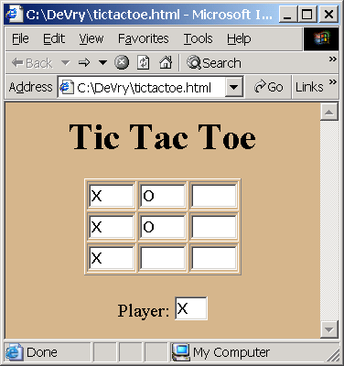

Get ready to program…
- Open and Size Notepad. Click on Start – Run. Type in Notepad. Click OK. Notepad comes up. If Notepad comes up in full screen, click on the restore icon (double boxes in upper right of window). Move Notepad to the upper left of your screen (click on the word “Notepad” at the top and drag it). Size Notepad (click on bottom right corner or some edge until the mouse pointer turns into a double arrow and drag) so that it takes up the left half or 2/3 of your screen.

- Create an empty html page. Here’s how we create a boring html file that has NOTHING IN IT!!! Type this into notepad. Then click on File – Save As. Save the file in \My Documents\ with file name tictactoe.html.

<html>

<head>
</head>

<body>
</body>

</html>

Web pages are made up of tags (e.g., html, head, body). Most tags have a beginning part (e.g., <body>) and an ending part (e.g., </body>). Tags must be properly nested – this is to say, a tag’s beginning part and ending part must both be inside of another tag – not half in and half out. The body is where we put content like words or pictures. The head is where we put other things – you’ll see some examples later.

- Launch the empty html page in the browser. Right click on Start, click on Explore. Find My Documents. Double click on tictactoe.html and you should see this – an empty html document. Move and size this window (as you did with the notepad window) so that it takes up the right half or one third of your screen.

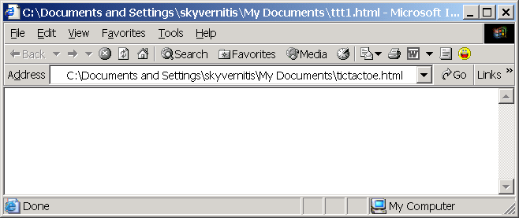

Not too exciting yet…

- Let’s add “Tic Tac Toe” as a heading in our webpage. To put the biggest heading, we’ll use the <h1> tag. Where shall we put it? In the header? In the body? Note that the <h1> shows where the heading starts and the </h1> shows Answer:

<html>

<head>
</head>

<body>
<h1>Tic Tac Toe </h1>
</body>

</html>

- Save your HTML and Refresh your web page. To save your HTML, click on File – Save from notepad. To Refresh your web page, click on the URL (where it says something like C:\Documents and Settings\skyvernitis\My Documents\tictactoe.html) and press the enter key from your keyboard. Now you should see this:

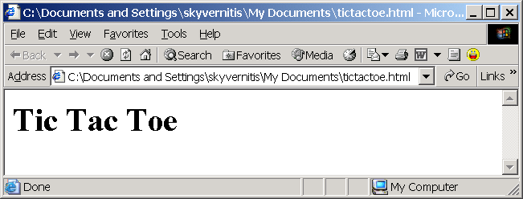

- Let’s add a little color and centering. Here’s an example of something (not content, not a picture) that goes in the head section. We’ll add the color inside a style tag (see below). The example below chooses “tan” as its background color. If you would like to select your own color, here are a few more choices (you can substitute for “tan” in the code below).

Color Name | Color |  | Color Name | Color |  | Color Name | Color |  | Color Name | Color
Lavender |  |  | DeepSkyBlue |  |  | DarkKhaki |  |  | Red
Orchid |  |  | Aqua |  |  | Gold |  |  | Chocolate
DarkOrchid |  |  | LimeGreen |  |  | Orange |  |  | Sienna
LightCyan |  |  | Chartreuse |  |  | Salmon |  |  | Wheat

<html>

<head>
<style>
body { background-color:tan; text-align:center}
</style>
</head>

<body>
<h1>Tic Tac Toe </h1>
</body>

</html>

After saving from notepad and refreshing the browser, we should see this:

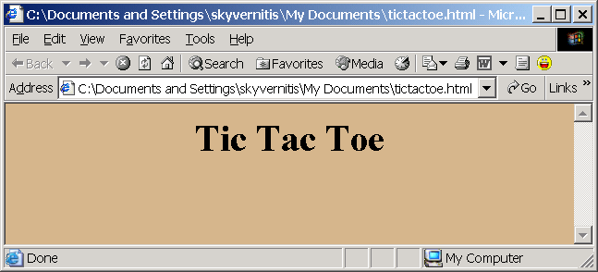

- Let’s add in the player. The Tic Tac Toe game uses textboxes to show who’s turn it is and what plays have been made. In HTML, textboxes need to be inside a “form.” So, first we insert a form (beginning and ending tags) into our body, and then we label our player textbox (“Player:”), then we insert the player textbox <input … > inside the form (as shown below).

Note that tags (e.g., form, input) can have attributes. In the example below, the form has a name attribute with value “tform”. This is so we can reference the form when we start writing the logic of the game into the program. Also note that the input tag has a name attribute = “player”, a size attribute specified at “1”, and its value attribute set to “X”. “X” will display in the textbox when we launch our game because we want player X to start first.

<html>
<head>
<style>
body { background-color:tan; text-align:center }
</style>
</head>
<body>
<h1>Tic Tac Toe </h1>
<form name="tform">

<br>
Player: <input name="player" size="1" value="X">

</form>
</body>
</html>

After saving from notepad and refreshing the browser, we should see this:

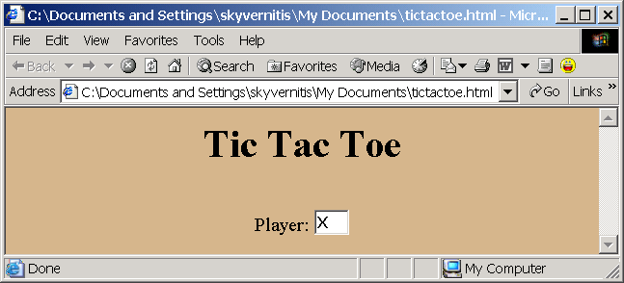

- Let’s add a little script. Suppose we wanted our Tic Tac Toe game to be friendlier than your average, run of the mill game. We’ll make it so that if the user clicks on the player textbox, they’ll get a greeting. To do this, we’ll (1) add function “say_hi” inside script tags in the header (see below) and (2) make a call to function “say_hi” whenever the user click on the player textbox (see “onclick=” below).

<html>
<head>
<style>
body { background-color:tan; text-align:center }
</style>
<script>
function say_hi( ) {
alert("hi");
}
</script>
</head>
<body>
<h1>Tic Tac Toe </h1>
<form name="tform">
<br> Player: <input name="player" size="1" value="X" onclick="say_hi( )" >
</form>
</body>
</html>

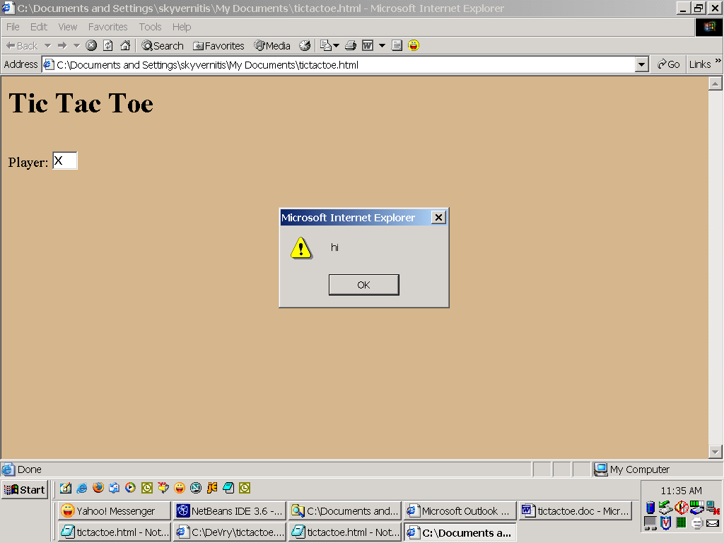

Save the HTML from notepad, refresh your browser, then click on the player textbox (the white box). You should see the Hi Message as shown above.

- What if I make a mistake??? Let’s say you misspelled something. For example, you might have typed onclick="say_hy( )" instead of onclick="say_hi( )". When you click on the player textbox, you’ll see no message and you’ll see “Error on Form” in the lower left of your browser. This is not very informative and it is the reason why programmers should always make one little change at a time and test between each change. Then, you can usually assume the problem you are having is due to the last thing you changed.

- Let’s add in the game board and a make Xs appear whenever they click on a Tic Tac Toe cell. We’ll use an HTML table o represent the Tic Tac Toe game board. An HTML table <table> has rows <tr> and rows have cell data <td>. Like most other HTML tags, everything needs to be properly nested. For our game, we’ll have 3 rows <tr>…</tr>, each having 3 cells <td>…</td> inside. Inside each of the 9 cells, we’ll add a textbox to hold the player’s moves (X or O). . Add the table as shown below.

We’ll also add a function that sets the value of a cell whenever a player clicks on that cell. Note that to “get at” the value of the player textbox, we must reference document.tform.player.value, which means the value of the player textbox that’s on the form that’s on the document. (Sound like “The House that Jack Built”?) Look at the onclick attribute of the textboxes in the table cells. See how they pass “this” as input to the function “set”? “this” actually means document.tform.what_was_clicked. Look at the set function (in the script section in the head). Note that when the “set” function gets it’s input, it is now called “cell”. Regardless of the fact that “this” changes its name to “cell” once the control passes to the “set” function, “this” and “cell” both mean the same (document.tform._what_was_clicked.) So, we only need to add the “.value” to the end of “cell” to specify that we want to set the VALUE of the cell that was clicked.
<html>
<head>
<style>
body { background-color:tan; text-align:center }
</style>
<script>
function say_hi( ) {
alert("hi");
}
function set(cell) {
cell.value=document.tform.player.value;
}
</script>
</head>
<body>
<h1>Tic Tac Toe </h1>
<form name="tform">
<table border="1">
<tr>
<td><input name="a1" size="3" onclick="set(this)"></td>
<td><input name="b1" size="3" onclick="set(this)"></td>
<td><input name="c1" size="3" onclick="set(this)"></td>
</tr>
<tr>
<td><input name="a2" size="3" onclick="set(this)"></td>
<td><input name="b2" size="3" onclick="set(this)"></td>
<td><input name="c2" size="3" onclick="set(this)"></td>
</tr>
<tr>
<td><input name="a3" size="3" onclick="set(this)"></td>
<td><input name="b3" size="3" onclick="set(this)"></td>
<td><input name="c3" size="3" onclick="set(this)"></td>
</tr>
</table>
<br> Player: <input name="player" size="1" value="X" onclick="say_hi( )" >
</form>
</body>
</html>

Save and refresh. Your board should now look like the target. Also, when you click on any cell, the “set” function is called and it copies the value of player (in this case always “X”) into the cell that was clicked.

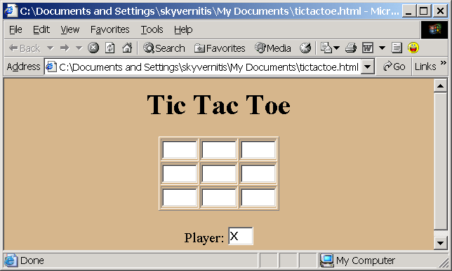

- Let’s add a function to switch player whenever a move is made. So, whenever “X” is done moving, player will switch to “O” and vice versa. Note that we could have just added the logic from function change_player right into function set, but we like to keep our code neat, simple, and organized.

<html>
<head>
<style>
body { background-color:tan; text-align:center }
</style>
<script>
function say_hi( ) {
alert("hi");
}
function set(cell) {
cell.value=document.tform.player.value;
change_player( );
}
function change_player( ) {
if (document.tform.player.value == "X")
document.tform.player.value="O"
else
document.tform.player.value="X";
}
</script>
</head>
<body> … </body>
</html>

Save and refresh. Now when you run the game, you’ll see that the player alternates (between X and O) each time a move is made. Like before, when the user clicks on a Tic Tac Toe cell, the value of player (X or O) is copied into that cell.
- Let’s add logic to prevent someone from moving into a cell that already has a move in it. This introduces a new programming construct – the if statement. It tests a condition, then executes one of two possible outcomes - based on whether the condition was true or false. The || means OR. Save and refresh. Test your game.

function set(cell) {
if (cell.value==null || cell.value=="") {
cell.value=document.tform.player.value;
change_player( );
}
else
alert ("Sorry you can't move there.");
}

- This game is great, but NO ONE EVER WINS !!! Let’s add a function to check for a winner. This is the last job and it is the hardest work – even with copying and pasting. Well, there are lot’s of ways to win in Tic Tac Toe ! Note how function “check_win” looks for a win in each row, each column, and the two diagonals. At the end of the function, if there was no winner, the value of variable “winner” will be “”. Since the value of “winner” is important to function “set”, function “check_win” returns it to function “set”. Function “set” uses this value to recognize that play should continue (so player should be switched) or that play should be halted and a congratulatory message displayed!

function set(cell)
{
if (cell.value==null || cell.value=="") {
cell.value=document.tform.player.value;
how_won = check_win( );
if (how_won == "")
change_player( );
else
alert ("You WON (" + how_won + ") !!!"
+ " Click on the URL and hit enter to play again.");
}
else
alert ("Sorry you can't move there.");
}

function check_win ( ) {
winner="";

if (document.tform.a1.value==document.tform.b1.value
&& document.tform.b1.value==document.tform.c1.value
&& document.tform.c1.value==document.tform.player.value)
winner = "Row 1";
else if (document.tform.a2.value==document.tform.b2.value
&& document.tform.b2.value==document.tform.c2.value
&& document.tform.c2.value==document.tform.player.value)
winner = "Row 2";
else if (document.tform.a3.value==document.tform.b3.value
&& document.tform.b3.value==document.tform.c3.value
&& document.tform.c3.value==document.tform.player.value)
winner = "Row 3";
else if (document.tform.a1.value==document.tform.a2.value
&& document.tform.a2.value==document.tform.a3.value
&& document.tform.a3.value==document.tform.player.value)
winner = "Column A";
else if (document.tform.b1.value==document.tform.b2.value
&& document.tform.b2.value==document.tform.b3.value
&& document.tform.b3.value==document.tform.player.value)
winner = "Column B";
else if (document.tform.c1.value==document.tform.c2.value
&& document.tform.c2.value==document.tform.c3.value
&& document.tform.c3.value==document.tform.player.value)
winner = "Column C";
else if (document.tform.a1.value==document.tform.b2.value
&& document.tform.b2.value==document.tform.c3.value
&& document.tform.c3.value==document.tform.player.value)
winner = "Top Left to Bottom Right";
else if (document.tform.a3.value==document.tform.b2.value
&& document.tform.b2.value==document.tform.c1.value
&& document.tform.c1.value==document.tform.player.value)
winner = "Bottom Left to Top Right";

return winner;
}

- This game works well, now, but the user might need a little more instruction. (They might think they are supposed to type an X or an O in the cells.) So, let’s add this “Click on a cell to make your move !” under the Tic Tac Toe heading. (see final, complete program on next page).

Here’s the final program, in its entirety.
<html>
<head>
<style>
body { background-color:tan; text-align:center }
</style>
<script>
function say_hi( ) {
alert("hi");
}
function set(cell) {
if (cell.value==null || cell.value=="") {
cell.value=document.tform.player.value;
how_won = check_win( );
if (how_won == "")
change_player( );
else
alert ("You WON (" + how_won + ") !!!"
+ " Click on the URL and hit enter to play again.");
}
else
alert ("Sorry you can't move there.");
}
function check_win ( ) {
winner="";
if (document.tform.a1.value==document.tform.b1.value
&& document.tform.b1.value==document.tform.c1.value
&& document.tform.c1.value==document.tform.player.value)
winner = "Row 1";
else if (document.tform.a2.value==document.tform.b2.value
&& document.tform.b2.value==document.tform.c2.value
&& document.tform.c2.value==document.tform.player.value)
winner = "Row 2";
else if (document.tform.a3.value==document.tform.b3.value
&& document.tform.b3.value==document.tform.c3.value
&& document.tform.c3.value==document.tform.player.value)
winner = "Row 3";
else if (document.tform.a1.value==document.tform.a2.value
&& document.tform.a2.value==document.tform.a3.value
&& document.tform.a3.value==document.tform.player.value)
winner = "Column A";
else if (document.tform.b1.value==document.tform.b2.value
&& document.tform.b2.value==document.tform.b3.value
&& document.tform.b3.value==document.tform.player.value)
winner = "Column B";
else if (document.tform.c1.value==document.tform.c2.value
&& document.tform.c2.value==document.tform.c3.value
&& document.tform.c3.value==document.tform.player.value)
winner = "Column C";
else if (document.tform.a1.value==document.tform.b2.value
&& document.tform.b2.value==document.tform.c3.value
&& document.tform.c3.value==document.tform.player.value)
winner = "Top Left to Bottom Right";
else if (document.tform.a3.value==document.tform.b2.value
&& document.tform.b2.value==document.tform.c1.value
&& document.tform.c1.value==document.tform.player.value)
winner = "Bottom Left to Top Right";
return winner;
}
function change_player( ) {
if (document.tform.player.value == "X")
document.tform.player.value="O"
else
document.tform.player.value="X";
}
</script>
</head>
<body>
<h1>Tic Tac Toe </h1>
Click on a cell to make your move !
<br>
<form name="tform">
<table border="1">
<tr>
<td><input name="a1" size="3" onclick="set(this)"></td>
<td><input name="b1" size="3" onclick="set(this)"></td>
<td><input name="c1" size="3" onclick="set(this)"></td>
</tr>
<tr>
<td><input name="a2" size="3" onclick="set(this)"></td>
<td><input name="b2" size="3" onclick="set(this)"></td>
<td><input name="c2" size="3" onclick="set(this)"></td>
</tr>
<tr>
<td><input name="a3" size="3" onclick="set(this)"></td>
<td><input name="b3" size="3" onclick="set(this)"></td>
<td><input name="c3" size="3" onclick="set(this)"></td>
</tr>
</table>
<br> Player: <input name="player" size="1" value="X">
</form>
</body>
</html>

